Unit 1:

Drawbacks of File system
- Data redundancy: Data redundancy refers to the duplication of data, lets say we are managing the data of a college where a student is enrolled for two courses, the same student details in such case will be stored twice, which will take more storage than needed. Data redundancy often leads to higher storage costs and poor access time.
- Data inconsistency: Data redundancy leads to data inconsistency, lets take the same example that we have taken above, a student is enrolled for two courses and we have student address stored twice, now lets say student requests to change his address, if the address is changed at one place and not on all the records then this can lead to data inconsistency.
- Data Isolation: Because data are scattered in various files, and files may be in different formats, writing new application programs to retrieve the appropriate data is difficult.
- Dependency on application programs: Changing files would lead to change in application programs.
- Atomicity issues: Atomicity of a transaction refers to “All or nothing”, which means either all the operations in a transaction executes or none.
For example: Let’s say Steve transfers 100$ to Negan’s account. This transaction consists multiple operations such as debit 100$ from Steve’s account, credit 100$ to Negan’s account. Like any other device, a computer system can fail lets say it fails after first operation then in that case Steve’s account would have been debited by 100$ but the amount was not credited to Negan’s account, in such case the rollback of operation should occur to maintain the atomicity of transaction. It is difficult to achieve atomicity in file processing systems.
- Data Security: Data should be secured from unauthorised access, for example a student in a college should not be able to see the payroll details of the teachers, such kind of security constraints are difficult to apply in file processing systems.

Introduction of DBMS
DBMS (Database Management System) is a software system that manages, stores, and retrieves data efficiently in a structured format.
- It allows users to create, update, and query databases efficiently.
- Ensures data integrity, consistency, and security across multiple users and applications.
- Reduces data redundancy and inconsistency through centralized control.
- Supports concurrent data access, transaction management, and automatic backups

Difference between Database and DBMS?

Category | Database | DBMS (Database Management System)
Definition | A systematic collection of related information or data. | A software application used to create, manage, retrieve, and update a database.
Function | Stores data efficiently. Can exist on paper or digitally. | Manages data, handles queries, enforces security and integrity, and provides an interface for user interaction.
Nature | Data (an entity). | Software (a set of programs).
Access | Data retrieval can be done manually or via queries when using a DBMS. | Data is typically retrieved using specific query languages like SQL, which the DBMS processes.
Security | Does not inherently provide security or access control on its own. | Ensures data security through user authentication and access controls.
Examples | A library's record of books, a company's customer records, a spreadsheet of contacts. | MySQL, Oracle, Microsoft SQL Server, PostgreSQL, MongoDB.

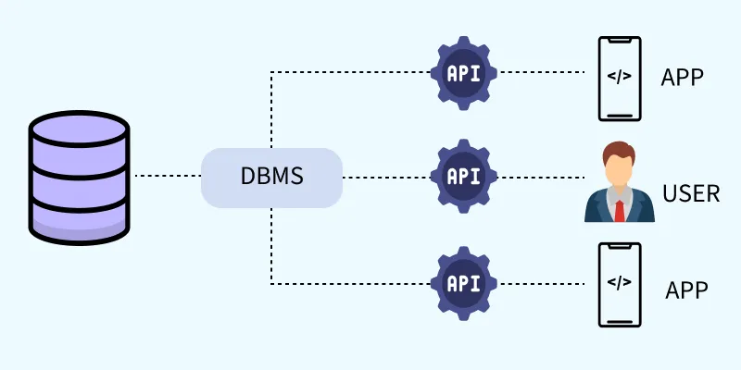
DBMS acts as a bridge between a central database and multiple clients-including apps and users. It uses APIs to handle data requests, enabling apps and users to interact with the database securely and efficiently without directly accessing the data.
A DBMS (Database Management System) works like a middleman between the database and the users or applications.
Think of the database as a store room where all data is kept safely.
Users and apps do not go directly into this store room.
Instead, they send their requests (like save data, search data, or update data) to the DBMS.
The DBMS uses APIs to understand these requests, checks whether the request is allowed, and then safely gets the required data from the database.
This way:
- Data remains secure
- Multiple users can work at the same time
- Errors and misuse of data are avoided
So, DBMS acts as a bridge that allows users and applications to use data easily, safely, and efficiently without directly touching the database.

How does a DBMS use APIs?
An API (Application Programming Interface) is like a set of rules or commands that allows applications to talk to the DBMS.
When a user uses an app (for example, a college portal or library system), the app does not directly access the database.

Instead, the process works like this:
- User gives input
Example: A student searches for their marks.
- Application sends a request using an API
The app sends a request such as “Give marks of student Roll No. 25” to the DBMS.
- API passes the request to the DBMS
The API acts as a messenger that carries the request in a proper format (like SQL commands).
- DBMS processes the request
  - Checks if the user is authorized
  - Checks if the request is valid
  - Finds the required data in the database
- DBMS sends the result back through the API
The data (marks) is sent back to the application.
- Application shows the result to the user
The student sees their marks on the screen.

Why APIs are important in DBMS?
- Apps do not need to know how data is stored
- Database remains secure
- Same database can be used by multiple applications
- Changes in database do not affect the application directly

Simple Real-Life Example
Think of a restaurant:
- Kitchen = Database
- Waiter (API) = Takes order and brings food
- Customer (User/App) = Places order
Customers never enter the kitchen.
They place orders through the waiter (API).

Problems with Traditional File-Based Systems
Before the introduction of modern DBMS, data was managed using basic file systems on hard drives. While this approach allowed users to store, retrieve and update files as needed, it came with numerous challenges
- Data Redundancy: Duplicate entries across files
- Inconsistency: Conflicting or outdated information
- Difficult Access: Manual file search required
- Poor Security: No control over data access
- Single-User Access: No support for collaboration
- No Backup/Recovery: Data loss was often permanent

What is a database?
- A database is an organized collection of information that can be searched, sorted, and updated. This data is often stored electronically in a computer system called a database management system (DBMS).
- Databases typically organize data in rows and columns for easy processing and retrieval. Oftentimes, you’ll need to use a programming language, such as structured query language (SQL), to interact with your database.
- Databases are similar to spreadsheets, but there are several key differences. In general, databases are much larger than spreadsheets, can store more data, and allow for multiple users to access data at the same time.
- For these reasons, people who work with data, such as data analysts and data scientists, often work with databases rather than spreadsheets.

- What is structured query language (SQL)?
SQL is a programming language used on almost all relational databases to query and manipulate data. It is still widely used today for querying databases to access the right data needed, but new languages have begun to appear in this space.

Applications of DBMS
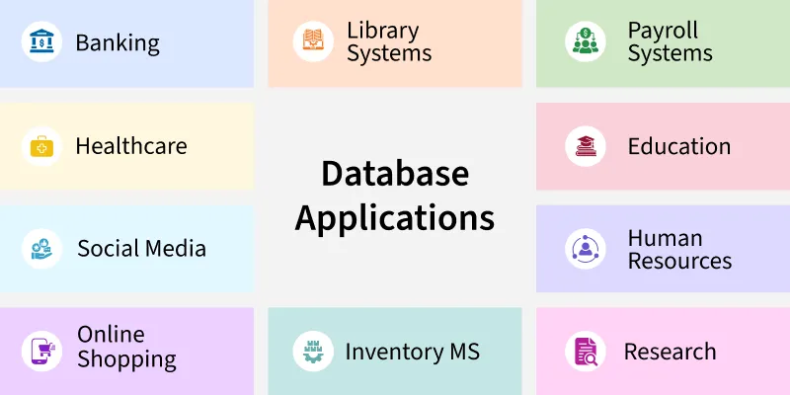
- Banking: Manages accounts and transactions.
- E-commerce: Tracks products, orders, and customers.
- Healthcare: Stores patient records and diagnoses.
- Education: Handles student grades and schedules.
- Social media: Manages user profiles and interactions.
- Data Science: Supports analytics and predictions.

Difference Between File System and DBMS
Basics | File System | DBMS
Structure | The file system is a way of arranging the files in a storage medium within a computer. | DBMS is software for managing the database.
Data Redundancy | Redundant data can be present in a file system. | In DBMS there is no redundant data.
Backup and Recovery | It doesn't provide Inbuilt mechanism for backup and recovery of data if it is lost. | It provides in house tools for backup and recovery of data even if it is lost.
Query processing | There is no efficient query processing in the file system. | Efficient query processing is there in DBMS.
Consistency | There is less data consistency in the file system. | There is more data consistency because of the process of normalization .
Complexity | It is less complex as compared to DBMS. | It has more complexity in handling as compared to the file system.
Security Constraints | File systems provide less security in comparison to DBMS. | DBMS has more security mechanisms as compared to file systems.
Cost | It is less expensive than DBMS. | It has a comparatively higher cost than a file system.
Data Independence | There is no data independence. | In DBMS data independence exists, mainly of two types:  1) Logical Data Independence .  2)Physical Data Independence.
User Access | Only one user can access data at a time. | Multiple users can access data at a time.
Meaning | The users are not required to write procedures. | The user has to write procedures for managing databases
Sharing | Data is distributed in many files. So, it is not easy to share data. | Due to centralized nature data sharing is easy
Data Abstraction | It give details of storage and representation of data | It hides the internal details of Database
Integrity Constraints | Integrity Constraints are difficult to implement | Integrity constraints are easy to implement
Example | Cobol , C++ | Oracle , SQL Server

DBMS Three-Level Architecture
To understand data independence, it’s essential to know how DBMS is organized:
- Internal Level : Deals with physical storage (files, indexing, compression).
- Conceptual Level : Describes structure like tables, fields and relationships.
- View Level : Defines how users and applications see the data.
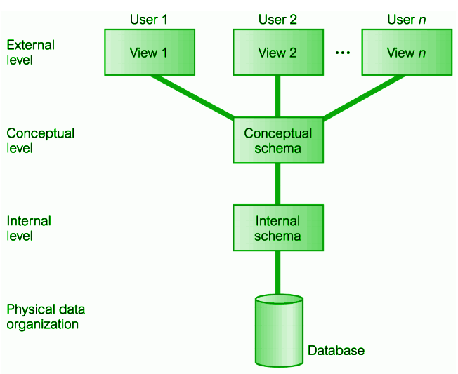
Data independence exists between these levels:
- Physical Data Independence: Change in the internal level without affecting the logical level.
- Logical Data Independence: Change in the logical level without affecting the view level.

Limitations/Disadvantages of file processing systems
The following issues are related to the file-based approach:
- Distinguished and Isolated Data: Imagine a user needs information that is not possible to be provided using a single file, multiple different files were required, which are situated in different departments. So all the employees first need to manually and carefully check each of the files in each department and find the relationship between them to decipher the information that the user wants.
- Data Duplication / Data Redundancy - Due to the manual storing of data, the same data used to be present in multiple locations using the space in each of the Hard Disk, below are some following reasons for which Data Redundancy can be a major issue
  - Storing the same data multiple times not only wastes resources in every machine but also is costly to maintain and wastes time
  - .
  - Loss of data integrity is another major issue of Data Redundancy, imagine someone's address is present in multiple systems and he has applied to update the address, in one system the address gets updated but in the rest of them it remains the same, so the if someone from any different department where the data is not updated tries to send them any letter or something then it would go to a wrong address.
- Dependence on Data - Files and information were stored in a certain specific format in files which is hard coded by programmers in languages like C/C++, COBOL, etc. So if any of the file's format changes then the programmers need to update the code every time and the format of every piece of data stored in that file will be changed, which is a rigorous task for programmers.
- Data representation is challenging from the user's perspective - The data stored in files must be represented in such a manner that every user can understand that data clearly and easily, often it would become hectic as the programmers need to go through different systems and find the proper connection between data and merge them together and represent them in a more human-readable format
- Different file types - The file structure would vary based on the programming language that was used to store them, for example, if a system used COBOL to store certain data then the structure of that data would differ from the one written in C/C++.
- Data Protection - Data protection was very less due to different reasons like Data Redundancy, manual storing of data, easy access of confidential data by unauthorized parties, etc.
- Issues with Transactions - It didn't follow the ACID (Atomicity, Consistency, Isolation, and Durability) properties, for that if in the middle of any transaction the system crashed then it would leave the system in an inconsistent state.
- Concurrent issues - Two or more users can view the same file simultaneously, but the problem arises when they try to update the same file simultaneously.

Advantages of Database Management System
The advantages of database management systems are:
- Data Security: DBMS enhances data security through access control and encryption. It enforces privacy policies and prevents unauthorized access. As user numbers grow, it mitigates associated risks of breaches.
- Data integration: DBMS unifies data from different sources into a centralized system. This provides a coherent organizational view of operations. It helps to keep track of how one segment of the company affects another segment.
- Data abstraction: Since many complex algorithms are used by the developers to increase the efficiency of databases that are being hidden by the users through various data abstraction levels to allow users to easily interact with the system.
- Reduction in data Redundancy: DBMS avoids data duplication by enforcing unique constraints. It removes unnecessary repetitive entries in databases. This ensures efficient use of storage and improves consistency. for e.g. - If there are two same students in different rows, then one of the duplicate data will be deleted.
- Data sharing: A DBMS provides a platform for sharing data across multiple applications and users, which can increase productivity and collaboration.
- Data consistency and accuracy: DBMS enforces integrity constraints to maintain valid data. It minimizes discrepancies by syncing updates across all views. This reduces errors and ensures reliable & consistent data.
- Data organization: A DBMS provides a systematic approach to organizing data in a structured way, which makes it easier to retrieve and manage data efficiently.
- Efficient data access and retrieval: DBMS allows for efficient data access and retrieval by providing indexing and query optimization techniques which reduces time taken to retrieve large datasets. It boosts system performance and user satisfaction.
- Concurrency and maintained Atomicity: That means, if some operation is performed on one particular table of the database, then the change must be reflected for the entire database. The DBMS allows concurrent access to multiple users by using the synchronization technique.
- Scalability and flexibility: DBMS is highly scalable and can easily accommodate changes in data volumes and user requirements. It allows flexible schema modifications and expansion. This makes it ideal for dynamic organizational environments and can scale up or down depending on the needs of the organization.

Disadvantages of DBMS
There are many advantages and disadvantages of DBMS (Database Management System). The disadvantages of DBMS are explained below.
1. Increased Cost
These are different types of costs:
- Cost of Hardware and Software: This is the first disadvantage of the database management system. This is because, for DBMS, it is mandatory to have a high-speed processor and also a large memory size. After all, nowadays there is a large amount of data in every field which needs to be store safely and with security.
The requirement of this large amount of space and a high-speed processor needs expensive hardware and expensive software too. That is, there is a requirement for sophisticated hardware and software which means that we need to upgrade the hardware which is used for the file-based system. Hardware and Software, both require maintenance which costs very high. All the operating, Training (all levels including programming, application development, and database administration), licensing, and regulatory compliance costs very high.
- Cost of Staff Training: Educated staff (database administrator, application programmers, data entry operations) who maintains the database management system also requires a good amount. We need the database system designers to be hired along with application programmers. Alternatively, the services of some software houses need to be taken. So there is a lot of money which needs to be spent on developing software.
- Cost of Data Conversion: We need to convert our data into a database management system, there is a requirement of a lot of money as it adds to the cost of the database management system. This is because for this conversion we need to hire database system designers whom we have to pay a lot of money and also services of some software house will be required. All this shows that a high initial investment for hardware, software, and trained staff is required by DBMS. So, altogether Database Management System results in a costlier system.
2. Complexity: As we all know that nowadays all companies are using the database management system as it fulfills lots of requirements and also solves the problem. But a problem arises, that is all this functionality has made the database management system an extremely complex software. For the proper requirement of DBMS, it is very important to have a good knowledge of it by the developers, DBA, designers, and also the end-users. This is because if any one of them does not acquire proper and complete skills then this may lead to data loss or database failure.
These failures may lead to bad design decisions due to which there may be serious and bad consequences for the organization. So this complex system needs to be understood by everyone using it. As it cannot be managed very easily. All this shows that a database management system is not a child’s game as it cannot be managed very easily. It requires a lot of management. A good staff is needed to manage this database at times when it becomes very complicated to decide where to pick data from and where to save it.
3. Currency Maintenance: This is very necessary to keep your system current because efficiency which is one of the biggest factors and needs to be overlooked must be maximized. That is we need to maximize the efficiency of the database system to keep our system current. For this, frequent updation must be performed on all the components as new threats come daily. DBMS should be updated according to the current scenario. Also, security measures must be implemented. Due to advancement in database technology, training cost tends to be significant.
4. Performance: The traditional file system is written for small organizations and for some specific applications due to which performance is generally very good. But for the small-scale firms, DBMS does not give a good performance as its speed is very slow. As a result, some applications will not run as fast as they could. Hence it is not good to use DBMS for small firms. Because performance is a factor that is overlooked by everyone. If performance is good then everyone (developers, designers, end-users) will use it easily and it will be user-friendly too. As the speed of the system totally depends on the performance so performance needs to be good.
5. Frequency Upgrade/Replacement Cycles: Nowadays in this world, we need to stay up-to-date about the latest technologies, developments arriving in the market. Frequent upgrade of the products is done by the DBMS vendors to add new functionality to the systems. New upgrade versions of the software often come bundled. Sometimes these updates also need hardware upgrades. Sometimes these changes and updates are so fast that the users find it difficult to work with that system because it is not easy to learn new commands and understand them again when the new upgrades are done. All these upgrades also cost money to train users, designers, etc. to use the new features.
6.Complex Design: Database design is complex, difficult and time consuming.
7.Damaged Part : If one part of database is corrupted or damaged, then entire database may get affected.
8.Compatibility: DBMS software may not be compatible with other software systems or platforms, making it difficult to integrate with other applications.
9.Security: A DBMS can be vulnerable to security breaches if not properly configured and managed. This can lead to data loss or theft.
10.Data Isolation: Because data are scattered in various files, and files may be in different formats, writing new application programs to retrieve the appropriate data is difficult.
11. Difficulty in Accessing Data: Suppose that one of the university clerks needs to find out the names of all students who live within a particular postal-code area. The clerk asks the data-processing department to generate such a list. Because the designers of the original system did not anticipate this request, there is no application program on hand to meet it. There is, however, an application program to generate the list of all students. The university clerk has now two choices: either obtain the list of all students and extract the needed information manually or ask a programmer to write the necessary application program. Both alternatives are obviously unsatisfactory. Suppose that such a program is written, and that, several days later, the same clerk needs to trim that list to include only those students who have taken at least 60 credit hours. As expected, a program to generate such a list does not exist. Again, the clerk has the preceding two options, neither of which is satisfactory.
The point here is that conventional file-processing environments do not allow needed data to be retrieved in a convenient and efficient manner. More responsive data-retrieval systems are required for general use.
12.Data Redundancy and Inconsistency: Since different programmers create the files and application programs over a long period, the various files are likely to have different structures and the programs may be written in several programming languages. Moreover, the same information may be duplicated in several places (files). For example, if a student has a double major (say, music and mathematics) the address and telephone number of that student may appear in a file that consists of student records of students in the Music department and in a file that consists of student records of students in the Mathematics department. This redundancy leads to higher storage and access cost. In addition, it may lead to data inconsistency; that is, the various copies of the same data may no longer agree. For example, a changed student address may be reflected in the Music department records but not elsewhere in the system.
13.Integrity Problems: The data values stored in the database must satisfy certain types of consistency constraints. Suppose the university maintains an account for each department, and records the balance amount in each account. Suppose also that the university requires that the account balance of a department may never fall below zero. Developers enforce these constraints in the system by adding appropriate code in the various application programs. However, when new constraints are added, it is difficult to change the programs to enforce them. The problem is compounded when constraints involve several data items from different files.

Different Types of Database Users
A Database User is defined as a person who interacts with data daily for updating, reading, and modifying the given data. Database users can access and retrieve data from the database through the Database Management System (DBMS) applications and interfaces.

Types of Database Users
Database users are categorized based on their interaction with the database. There are seven types of database users in DBMS. Below mentioned are the types of database users:
1. Database Administrator (DBA)
A Database Administrator (DBA) defines the schema and manages all three levels of the database architecture. They create user accounts, control access, and ensure data security by authorizing only trusted users. DBAs are also responsible for handling security breaches and optimizing system performance.
- DBA also monitors the recovery and backup and provides technical support.
- The DBA has a DBA account in the DBMS which is called a system or superuser account.
- DBA repairs damage caused due to hardware and/or software failures.
- DBA is the one having privileges to perform DCL (Data Control Language) operations such as GRANT and REVOKE, to allow/restrict a particular user from accessing the database.
2. Naive / Parametric End Users
Parametric End Users are the unsophisticated who lacks DBMS knowledge but they frequently use the database applications in their daily life to get the desired results. For example, Railway’s ticket booking users, Clerks in any bank are naive user because they lacks DBMS knowledge but they still use the database.
3. A System Analyst
A system Analyst is a user who analyzes the requirements of parametric end users. They check whether all the requirements of end users are satisfied.
4. Sophisticated Users
Sophisticated users like engineers or analysts interact directly with the database using SQL queries. They don't write full application code but use the query processor to access and manipulate data. These users develop custom database applications based on their specific needs.
5. Database Designers
Database Designers create the structure of a database, including tables, views, indexes, triggers, and constraints. They decide what data to store and how it should be related based on user requirements. Their design is finalized before the database is built or populated with data.
6. Application Programmers
Application Programmers, also known as System Analysts or Software Engineers, write backend code for application programs. They use languages like C, Visual Basic, COBOL, etc., to design, test, and maintain programs. These programs, called "canned transactions," help naive users interact with the database efficiently.
7. Casual Users / Temporary Users
Casual Users are the users who occasionally use/access the database but each time when they access the database they require the new information, for example, Middle or higher level manager.
8. Specialized users
Specialized users are sophisticated users who write specialized database application that does not fit into the traditional data-processing framework. Among these applications are computer aided-design systems, knowledge-base and expert systems etc.

Structure of Database Management System
A Database Management System (DBMS) is software that allows users to define, store, maintain, and manage data in a structured and efficient manner. It acts as an intermediary between data and users, allowing disparate data from different applications to be managed. A DBMS simplifies the complexity of data processing by providing tools to organize data, ensure its integrity, and prevent unauthorized access or loss of data.
In today's data-driven world, DBMS are essential for applications such as banking systems, e-commerce platforms, education, and medical systems. They not only store and manage large amounts of data, but also provide functionality that provides performance, security, and scalability for multiple users with multiple access levels.
It also allows access to data stored in a database and provides an easy and effective method of:
- We are defining the information.
- Storing the information.
- Manipulating the information.
- We are protecting the information from system crashes or data theft.
- Differentiating access permissions for different users.
Understanding Data Theft in DBMS
Data theft means the illicit extraction or manipulation of sensitive information stored in databases, servers, and other storage systems. This is further defined, in DBMS, as improper access to confidential or sensitive data by unauthorized persons.
This may include information such as personal data, financial records, intellectual property, or trade secrets. As digital data storage has grown, so has the threat of data theft; it is now a primary priority concern with serious impacts on organizations worldwide.
Data theft can be carried out by, among others:
- Hacking and exploiting: Attackers can use DBMS security gaps to access unauthorized sensitive data.
- Insider threats: Employees or contractors compromise privileged access to information.
- Phishing and social engineering: These are techniques that will trick the authorized user into revealing the login credentials to enable intrusion.
- Malware and ransomware attacks: These are malware that make database security vulnerable to attack, thus giving access to attackers to steal data or lock down data until some amount of ransom is paid.
Data theft prevention is not only an issue in sensitive information matters but also for building trust between businesses and clients. Controls over access, periodic audits, real-time monitoring of activities done through the database are effective measures one could consider to reduce the risk. Also, following cyber security protocols and periodic inundation of database systems will reduce most of the vulnerabilities.
Database Architecture vs. Tier Architecture
Structure of Database Management System is also referred to as Overall System Structure or Database Architecture but it is different from the Tier architecture of Database.
- Database Architecture refers to the internal components of the DBMS, including the Query Processor, Storage Manager, and Disk Storage. It also defines the interaction of these components.
- Tier Architecture typically refers to the multi-layered setup in an application where DBMS serves as the data layer, but it is distinct from Database Architecture, which refers to the internal structure and levels (internal, conceptual, and external) of the DBMS.
Components of a Database System
Query Processor, Storage Manager, and Disk Storage. These are explained as following below.
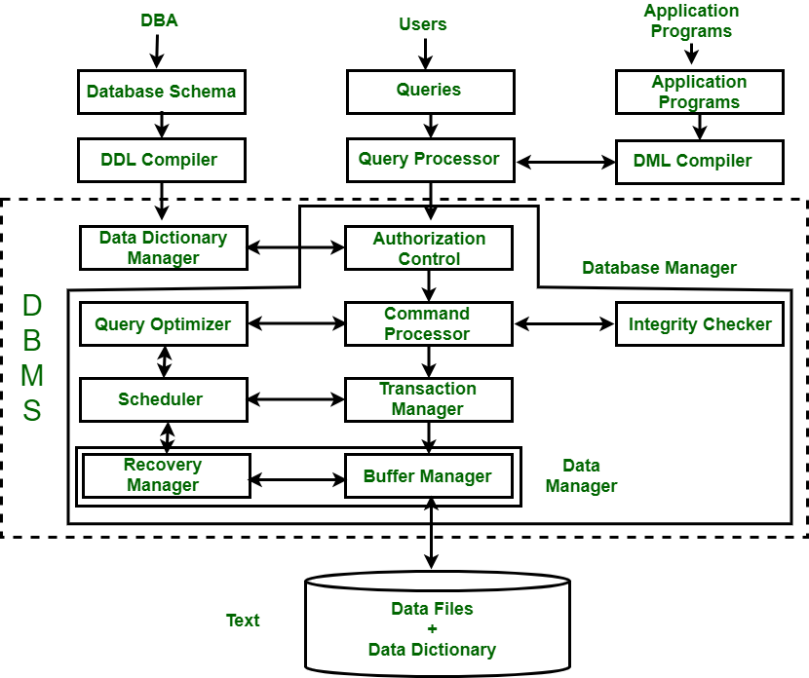
1. Query Processor
It interprets the requests (queries) received from end user via an application program into instructions. It also executes the user request which is received from the DML compiler. Query Processor contains the following components -
- DML Compiler: It processes the DML statements into low level instruction (machine language), so that they can be executed.
- DDL Interpreter: It processes the DDL statements into a set of table containing meta data (data about data).
- Embedded DML Pre-compiler: It processes DML statements embedded in an application program into procedural calls.
- Query Optimizer: The Query Optimizer executes instructions generated by the DML Compiler and improves query execution efficiency by choosing the best query plan, considering factors such as indexing, join order, and available system resources. For instance, if a query involves joining two large tables, the optimizer will select the best join order to minimize query execution time.
2. Storage Manager
Storage Manager is an interface between the data stored in the database and the queries received. It is also known as Database Control System. It maintains the consistency and integrity of the database by applying the constraints and executing the DCL statements. It is responsible for updating, storing, deleting, and retrieving data in the database. It contains the following components:
- Authorization Manager: It ensures role-based access control, i.e,. checks whether the particular person is privileged to perform the requested operation or not.
- Integrity Manager: It checks the integrity constraints when the database is modified.
- Transaction Manager: It controls concurrent access by performing the operations in a scheduled way that it receives the transaction. Thus, it ensures that the database remains in the consistent state before and after the execution of a transaction.
- File Manager: It manages the file space and the data structure used to represent information in the database.
- Buffer Manager: It is responsible for cache memory and the transfer of data between the secondary storage and main memory.
3. Disk Storage
It contains the following essential components:
- Data Files: It stores the actual data in the database.
- Data Dictionary: It contains the information about the structure of database objects such as tables, constraints, and relationships. It is the repository of information that governs the metadata.
- Indices: Provides faster data retrieval by allowing the DBMS to find records quickly, improving query performance.
Levels of DBMS Architecture
The structure of a Database Management System (DBMS) can be divided into three main components: the Internal Level, the Conceptual Level, and the External Level.
1. Internal Level
This level represents the physical storage of data in the database. It is responsible for storing and retrieving data from the storage devices, such as hard drives or solid-state drives. It deals with low-level implementation details such as data compression, indexing, and storage allocation.
2. Conceptual Level
This level represents the logical view of the database. It deals with the overall organization of data in the database and the relationships between them. It defines the data schema, which includes tables, attributes, and their relationships. The conceptual level is independent of any specific DBMS and can be implemented using different DBMSs.
3. External Level
This level represents the user's view of the database. It deals with how users access the data in the database. It allows users to view data in a way that makes sense to them, without worrying about the underlying implementation details. The external level provides a set of views or interfaces to the database, which are tailored to meet the needs of specific user groups.
Schema Mapping in DBMS
The three levels are connected via schema mapping, ensuring that changes at one level (e.g., the conceptual level) are accurately reflected in the others. This process maintains data independence, allowing changes in physical storage (internal level) without affecting the logical or user views.
Role of Database Administrator (DBA)
In addition to these three levels, a DBMS also includes a Database Administrator (DBA) component, which is responsible for managing the database system. The DBA performs critical tasks such as:
- Database design and architecture.
- Security management: Implementing role-based access control (RBAC), encryption, and ensuring strong authentication measures such as multi-factor authentication (MFA).
- Backup and recovery: Regularly creating backups and preparing recovery plans in case of data loss.
- Performance tuning: Optimizing database performance, including query optimization, indexing, and resource management to ensure the DBMS runs efficiently
Click here for more details

